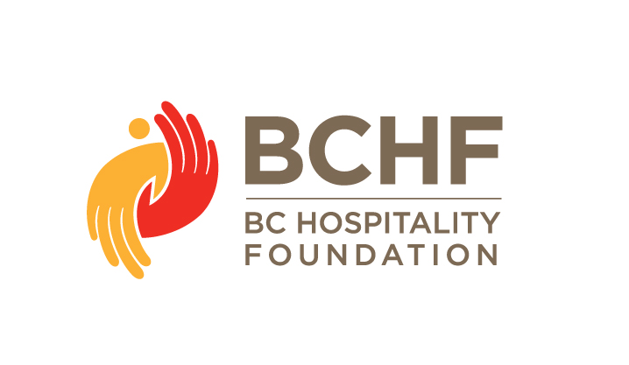
Auction Item Information
Thank you for supporting the BC Hospitality Foundation with your donation to our auction program. We want to ensure we have accurate information to promote your donation both at the event and online. Please complete the form below and send it to lucy@bchospitalityfoundation.com

Event name –  highlight one or all | DISH Golf Vancouver Golf Victoria
Contact name
Company
Address with postal
Phone
Email
Donation
Value
Exclusions
Social Media

Description(s) of Auction Item(s) to be used online and in print where applicable:

Vancouver event gift certificates/gift cards can be mailed to
BC Hospitality Foundation c/o Lucy Cayuela
3454 St. Georges Ave., North Vancouver, BC, V7N 1V8

Vancouver ISLAND golf gift certificates/gift cards can be mailed to
Debra Gibson
1435 Wende Rd., Victoria, BC, V8P 3T7

Thank you for supporting the BC Hospitality Foundation!
Warmest regards,

Dana
Dana Harris, Executive Director
BC Hospitality Foundation
604-986-3262
dana@danalee.biz

